Facial Expression Recognition using Convolutional Neural Networks
A
Major Project Report
Submitted in partial fulfilment of the requirements for the award of the degree of
BACHELOR OF TECHNOLOGY
In
COMPUTER SCIENCE & ENGINEERING
With Specialization
E-COMMERCE, RETAIL, & AUTOMATION
AND
BANKING, FINANCIAL SERVICES & INSURANCE
By
Abhishek Kumar | R114216003 | CSE-ECRA
Ankush Kumar | R133216005 | CSE-BFSI
Paras Sharma | R114216017 | CSE-ECRA
Vijay Chauhan | R114216035 | CSE-BFSI

Under the guidance of

Ms. Aradhana Kumari Singh
Assistant Professor, Department of Informatics
School Of Computer Science

SCHOOL OF COMPUTER SCIENCE
UNIVERSITY OF PETROLEUM & ENERGY STUDIES
Bidholi Campus, Energy Acres, Dehradun – 248007
Year – 2020

Candidate’s Declaration

I hereby certify that the project work entitled “Facial Expression Recognition using Convolutional Neural Networks” in partial fulfilment of the requirements for the award of the Degree of BACHELOR OF TECHNOLOGY in COMPUTER SCIENCE & ENGINEERING with specialization in E-COMMERCE, RETAIL & AUTOMATION and BANKING, FINANCIAL SERVICES & INSURANCE submitted to the School of Computer Science, Department of Informatics, University of Petroleum & Energy Studies, Dehradun, is an authentic record of my work carried out during a period from January,2020 to May,2020 under the supervision of Ms. Aradhana Kumari Singh, Department of Informatics. The matter presented in this project has not been submitted by me for the award of any other degree of this or any other University.

Abhishek Kumar | R114216003 | CSE-ECRA
Ankush Kumar | R133216005 | CSE-BFSI
Paras Sharma | R114216017 | CSE-ECRA
Vijay Chauhan | R114216035 | CSE-BFSI

This is to certify that the above statement made by the candidates is correct to the best of my knowledge.

Date: ______________

Dr. T.P. Singh Ms. Aradhana Kumari Singh
HOD- Informatics Project Guide
School of Computer Science
University of Petroleum & Energy Studies
Dehradun- 248001 (Uttarakhand)

Acknowledgement

We wish to express our deep gratitude to our guide Ms. Aradhana Kumari Singh, for all advice, encouragement and constant support she has given us throughout my project work. This work would not have been possible without her support and valuable suggestions.
We sincerely thank to our respected HoD of the Department, Dr. T.P. Singh, for his great support in doing our project in Object Detection & Image Recognition using Python at SoCS.
We are also grateful to Dr. Manish Prateek, Director, SoCS, UPES for giving us the necessary facilities to carry out our project work successfully.
We would like to thank all our friends for their help and constructive criticism during our project work. Finally, we have no words to express our sincere gratitude to our parents who have shown us this world and for every support, they have given us.

Abhishek Kumar | R114216003 | CSE-ECRA
Ankush Kumar | R133216005 | CSE-BFSI
Paras Sharma | R114216017 | CSE-ECRA
Vijay Chauhan | R114216035 | CSE-BFSI

Abstract

Facial expressions are very important in human-to-human communication. As interactive technology has become ubiquitous in our society and is taking on coaching roles in education, emotion recognition from facial expressions has become an important part in human computer interaction. However, human facial expressions change so frequently that automatic facial expression recognition has always been a difficult yet challenging task. Hence, we are going to use a method to achieve this using convolutional neural network.
Our goal will be to classify each facial expression image into one of the seven facial emotion categories considered in this project. We would be training CNN models with different depth using gray-scale images. We are going to develop our models in Keras and exploited Graphics Processing Unit (GPU) computation in order to expedite the training process. In addition to the networks performing based on raw pixel data, we will be employing a hybrid feature strategy by which we would train our CNN model with the combination of raw pixel data and Histogram of Oriented Gradients (HOG) features.

Keywords: Facial Expression Recognition, Graphical Processing Unit (GPU), Convolutional Neural Networks (CNN), Histogram of Oriented Gradients (HOG)

Introduction

Humans interact with one another mainly through speech, but also through body gestures, to stress certain parts of their speech and to display emotions. One of the important ways humans display emotions is through facial expressions which are a really important part of communication. Though nothing is claimed verbally, there's much to be understood about the messages we send and receive through the utilization of nonverbal communication. Facial expressions convey nonverbal clues, and they play an important role in interpersonal relations. Automatic recognition of facial expressions are often a crucial component of natural human-machine interfaces; it's going to even be utilized in behavioural science and in clinical practice. Although humans recognize facial expressions virtually without effort or delay, reliable expression recognition by machine remains a challenge. There are several advances within the past few years in terms of face detection, feature extraction mechanisms and therefore the techniques used for expression classification, but development of an automated system that accomplishes this task is difficult. In this project, we are going to present an approach based on Convolutional Neural Networks (CNN) for facial expression recognition. The input into our system is an image; then, we use CNN to predict the countenance label which should be one these labels: anger, happiness, fear, sadness, disgust and neutral.

Problem Statement

Humans interact with each other mainly through speech, but also through body gestures, to emphasize certain parts of their speech and to display emotions. One of the important ways humans display emotions is through facial expressions which are a very important part of communication. However, human facial expressions change so subtly that automatic facial expression recognition has always been a challenging task

Hence, the aim of this project is classify each facial image into one of the facial emotion categories using the concept of Convolutional Neural Networks.

Literature Review

Facial Expression Recognition

Facial expression recognition is an interesting and challenging problem which has important applications in many areas like human-computer interaction. It helps to build more intelligent robots which has the ability to understand human emotions. Also, some of the real-world applications such as call centre and interactive game development also benefit from such intelligence.

Ekman in early 1970s showed that there are six universal emotional expressions across all cultures, namely disgust, anger, happiness, sadness, surprise and fear. These expressions could be identified by observing the face signals. For example, a smile gesture by raising the mouth corners and tightening the eyelids is a signal of happiness.

Examples of seven facial emotions that we will consider in this classification problem. (1) Angry, (2)
Neutral, (3) sad, (4) happy, (5) surprise, (6) fear, (7) disgust

Due to the importance of facial expression recognition in designing human–computer interaction systems, various feature extraction and machine learning algorithms have been developed. Most of these methods deployed hand-crafted features followed by a classifier such as local binary pattern with SVM classification, Haar, SIFT, and Gabor filters with fisher linear discriminant, and also Local phase quantization (LPQ).

Convolutional Neural Network is considered as one of the best classifiers to solve the problem of facial expression recognition since it learns to extract the features directly from the training database using iterative algorithms like gradient descent. CNN is usually combined with feedforward neural network classifier which makes the model end-to-end trainable on the dataset.

Applications of Facial Expression Recognition

Facial Expression Recognition, also known as Emotion Recognition is a technique used in software that allows a program to "read" the emotions on a human face using advanced image processing. It has the following applications in different fields which are listed as follows:

- Retail

Based on the current customer and partners engagements, one of the most promising use cases is marketing/advertising. The customers want to know how people respond to ads, products, packaging and store design.

- Education

Education applications measure real-time learner responses to and engagement with educational content; adapt and personalize content; and measure effectiveness of lecturer.

- Security

It can identify people in a crowd, monitor citizens for suspicious behaviour by tracking identity, age, gender and current emotional state. It can be used to pre-emptively stop criminals and potential terrorists.

Convolutional Neural Network (CNN)
A Convolutional Neural Network (CNN) is mainly comprised of one or more convolutional layers and then followed by one or more fully connected layers as in a standard multilayer neural network. The architecture of a CNN is designed to take advantage of the 2D structure of an input image (or other 2D input such as a speech signal). This is achieved with local connections and tied weights followed by some form of pooling which results in translation invariant features. The main advantage of using CNN model is that they are easier to train and have many fewer parameters than fully connected networks with the same number of hidden units. CNN is one of the best classifiers used in Facial Expression Recognition due to following reasons:
- It learns to extract the features directly from the training database using iterative algorithms like gradient descent. CNN is usually combined with feedforward neural network classifier which makes the model end-to-end trainable on the dataset.
- Like ordinary neural network, CNN learns its weights using back-propagation algorithm. It has two main components namely local receptive fields and shared weights. In local receptive fields, each neuron is connected to a local group of the input space. The size of the group of the input space is equal to the filter size where the input space can either be pixels from the input image or features from the previews layer.
- The same weighs and bias are used over all local receptive fields in CNN model. Although these components make CNN runs faster, but they are prone to over-fitting as the same weights are applied to the entire image.

Contents of Convolutional Neural Networks
For the purpose of this project, first we built a shallow CNN. This network consists of two convolutional layers and one FC layer. In the first convolutional layer, we had 32 3X3 filters, with the stride of size 1, along with batch normalization and dropout, but without maxpooling.
In the second convolutional layer, we had 64 3X3 filters, with the stride of size 1, along with batch normalization and dropout and also max-pooling with a filter size 2X2. In the FC layer, we have a hidden layer with 512 neurons and Softmax as the loss function. Also in all the layers, we have used Rectified Linear Unit (ReLU) as the activation function.

The architecture of the deep network: 4 convolutional layers and 2 fully connected layers

Before training our model, we made it sure by some sanity checks that the implementation of the network was correct. For the first sanity check, we computed the initial loss when there is no regularization. Since our classifier has 7 different classes, we expected to get a value around 1.95. As the second sanity check, we tried to over fit our model using a small subset of the training set. Hence, our model cleared both of these checks.

For the training process, we used all of the images in the training set with 30 epochs and a batch size of 128 and cross-validated the hyper-parameters of the model with different values for regularization, learning rate and the number of hidden neurons.

To validate our model in each iteration, we used the validation set and to evaluate the performance of the model, we used the test set. The best shallow model, gave us 55% accuracy on the validation set and 54% on the test set.

To clarify the effect of adding convolutional layers and FC layers to the network, we trained a deeper CNN with 4 convolutional layers and two FC layers.

The first convolutional layer had 64 3X3 filters, the second one had 128 5X5 filters, the third one had 512 3X3 filters and the last one had 512 3X3 filters. In all convolutional layers, we have a stride of size 1, batch normalization, dropout, max-pooling and ReLU as the activation function. The hidden layer in the first FC layers had 256 neurons and the second FC layer had 512 neurons. In both FC layers, same as in the convolutional layers, we used batch normalization, dropout and ReLU. Also we used Softmax as our loss function.

As compared to our shallow model, before training the network, we performed initial loss checking and examined the ability of overfitting the network using a small subset of the training set. The results of these sanity checks proved that the implementation of the network was correct. Then, with the help of 35 epochs and a batch size of 128, we trained the network with all the images in the training set. Moreover, we cross-validated the hyper parameters to get the model with the highest accuracy. This time, we obtained an accuracy of 65% on the validation set and 64% on the test set.

Classification

Classification is defined as the process of predicting class or category from observed values or given data points. Mathematically, classification is the task of approximating a mapping function (f) from input variables (X) to output variables (Y). It is basically belongs to the supervised machine learning in which targets are also provided along with the input data set.
Following are the examples of cases where the data analysis task is Classification −
- A bank loan officer wants to analyse the data in order to know which customer (loan applicant) are risky or which are safe.
- A marketing manager at a company needs to analyse a customer with a given profile, who will buy a new computer.
In both of the above examples, a model or classifier is constructed to predict the categorical labels. These labels are risky or safe for loan application data and yes or no for marketing data.

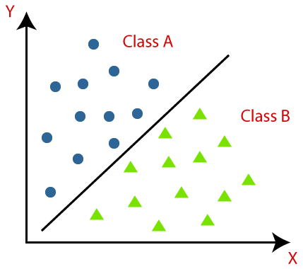

Types of Learners in Classification

- Lazy Learners
These learners would wait for the testing data to be appeared after storing the training data. Classification is done only after getting the testing data. They spend less time on training but more time on predicting. Examples of lazy learners are K-nearest neighbour and case-based reasoning.
- Eager Learners
Eager learners construct classification model without waiting for the testing data to be appeared after storing the training data. They spend more time on training but less time on predicting. Examples of eager learners are Decision Trees, Naïve Bayes and Artificial Neural Networks (ANN).

How Classification works

The Data classification process includes two process:

- Building a classifier model
- Using Classifier for classification
The algorithm which implements the classification on a dataset is known as a classifier. There are two types of Classifications:
- Binary Classifier: If the classification problem has only two possible outcomes, then it is called as Binary Classifier.
Examples: YES or NO, MALE or FEMALE, SPAM or NOT SPAM, CAT or DOG, etc.
- Multi-class Classifier: If a classification problem has more than two outcomes, then it is called as Multi-class Classifier.
Example: Classifications of types of crops, Classification of types of music.

How Convolutional Neural Networks work
When it comes to Image classification as when we have taken up this algorithm in this project, convolution neural networks is known to offer significant benefits as compared to normal neural networks. In such a case, the initial inputs would be images, made up of pixels. The traditional issue with image classification is that with big images, with many color channels, is that it quickly becomes computationally infeasible to train some models. What CNN tries to do is transform the images into a form which is easier to process, while still retaining the most important features. This is done by passing a filter over the initial image, which conducts matrix multiplication over a subsection of the pixels in the initial image, it iterates through subsets until it has considered all subsets. The filter aims at capturing the most crucial features, while allowing the redundant features to be eliminated. This passing of a filter over the initial pixels is kwon as convolutional layer.
After the convolution layer comes the pooling layer, where the spatial size of the convoluted features will be attempted to be reduced. The reduction in complexity, sometimes known as dimensionality reduction will decrease the computational cost of performing analysis on the data set, allowing the method to be more robust. In this layer, a kernel once again passes over all subsets of pixels of the image. There are two types of pooling kernels which are commonly used. The first one is Max Pooling, which retains the maximum value of the subset. The alternative kernel is average pooling, which does exactly what you’d expect: it retains the average value of all the pixels in the subset.

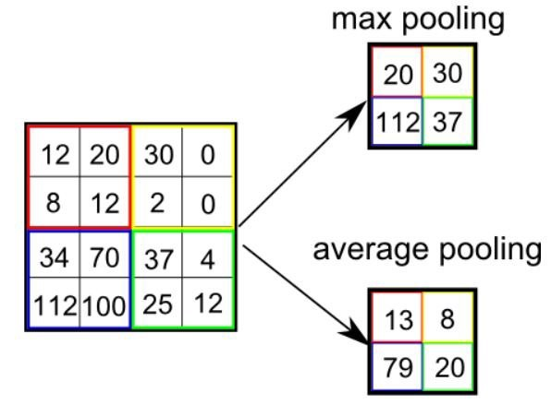
Pooling phase of Convolutional Neural Networks
After the pooling phase, the information will hopefully be compressed enough to be used in a regular neural network model. The last remaining thing to do is to flatten the final output of the pooling phase and feed it into the model. The flattening is done by changing the matrix of pixels into a vector of pixels, which can then be used for the neural net model.
From there, the convolution neural network acts just like a regular neural network, in that the information will be passed to a set of neurons, which will pass on values to other layers until a final output is reached.

Objective

The aim of this project is to classify each facial image into one of the facial emotion categories using the concept of Convolutional Neural Networks.

The dataset that we are using is taken from Kaggle website and the name of dataset is FER 2013. This dataset comprises of 28709 training images: 3589 validation (public) and 3589 test (private) divided into seven different classes of expression Angry, Disgust, Fear, Happy, Sad, Surprise and Neutral.

Use Case (FER System)

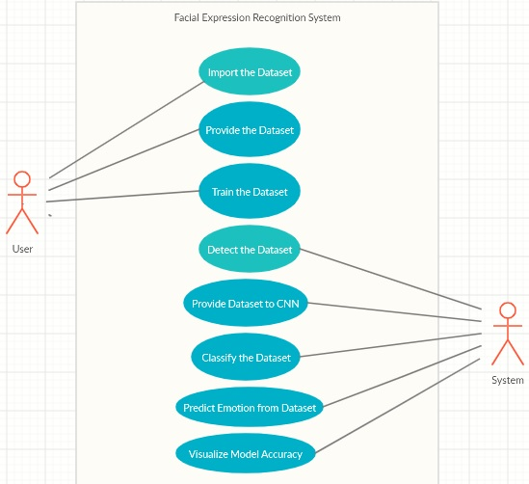

Class Diagram (FER System)

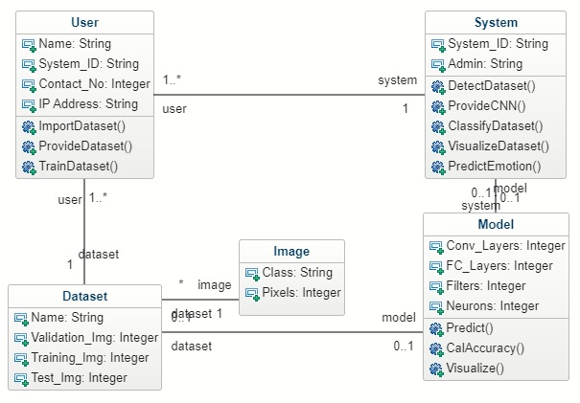

Object Diagram (FER System)

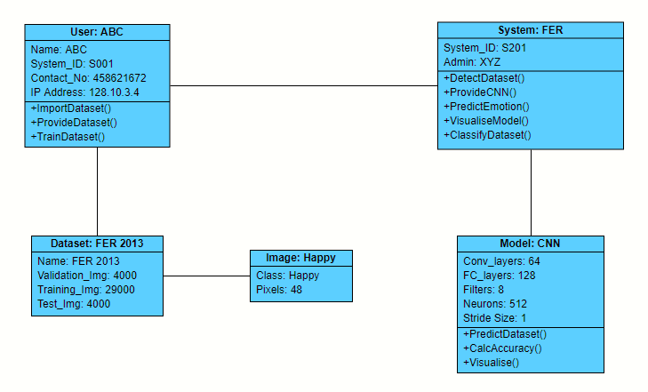

Methodology

FER DATASET

The FER 2013 dataset comprises of 28709 training images: 3589 validation (public) and 3589 test (private) divided into seven different classes of expression Angry, Disgust, Fear, Happy, Sad, Surprise and Neutral. Due to label noise, the human accuracy of this dataset is 68%.

The dataset consists of 48x48 pixel grayscale images of faces. The faces have been automatically registered in order the face is more or less centered and occupies about the same amount of space in each image. Our aim is to classify each face based on the emotion shown in the facial expression in to one of seven categories.

Selecting and Importing Dataset

This dataset is taken from Kaggle website, which consists of about 37,000 well-structured 48 X 48 pixel gray-scale images of faces. The images present in dataset are processed in such a way that the faces are almost centered and each face occupies about the same amount of space in each image.

Each image will be classified into one of the seven classes that express different facial emotions. These facial emotions have been categorized as: 0=Angry, 1=Disgust,
2=Fear, 3=Happy, 4=Sad, 5=Surprise, and 6=Neutral.

The given images are divided into three different sets which are training, validation, and test sets. We have taken around 29,000 training images, 4,000 validation images, and 4,000 images for testing.

COLLECTING DATASET FOR FACIAL EXPRESSION RECOGNITION & TRAINING DATASET

- For implementing this project, we have already downloaded the FER dataset which includes around 37,000 well-structured 48 X 48 pixel gray-scale images of faces. The images present in the dataset are processed in such a way that the faces are almost centered and each face occupies about the same amount of space in each image.

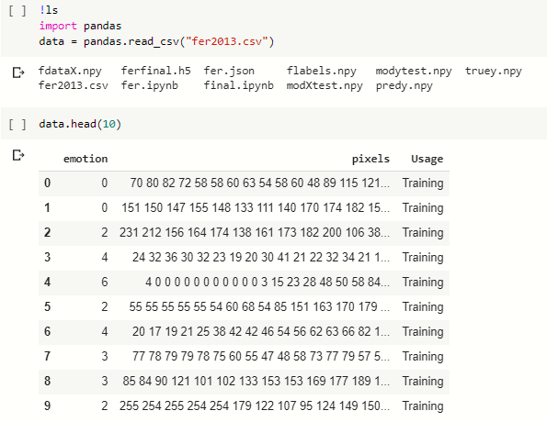

- Each image has to be classified into one of the seven classes that express different facial emotions. These facial emotions are given as follows: 0=Angry, 1=Disgust, 2=Fear, 3=Happy, 4=Sad, 5=Surprise, and 6=Neutral.

The given images are divided into three different sets which are training, validation, and test sets. We have around 29,000 training images, 4,000 validation images, and 4,000 images for testing.

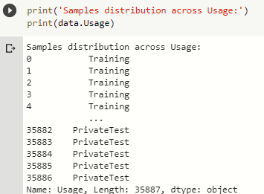

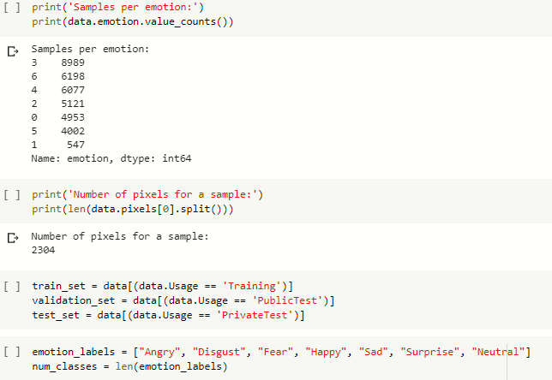

- After importing the dataset, we will be pre-processing our dataset which gives us the details about the number of features, no of labels and the given images present in dataset.

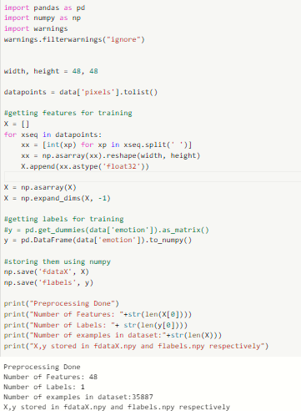

- Now we will import the settings for Keras for machine learning tool and data analysis tools such as NumPy and pandas for implementing our dataset and provide to for the model. First of all, we will visualize the images present in our dataset.

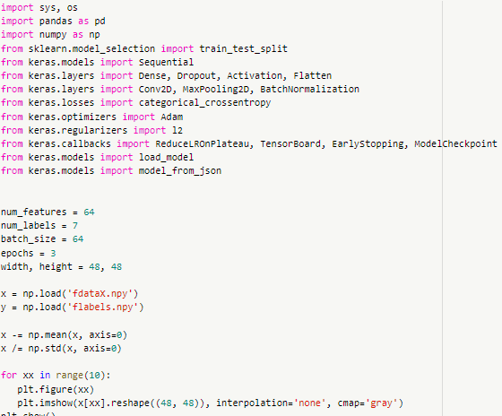

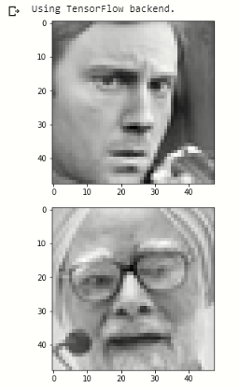
- Now, we will compose the CNN model and we will define the features, labels and batch size for the model. For instance, we will be training our datasets for at least 3 epochs to attain some accuracy.

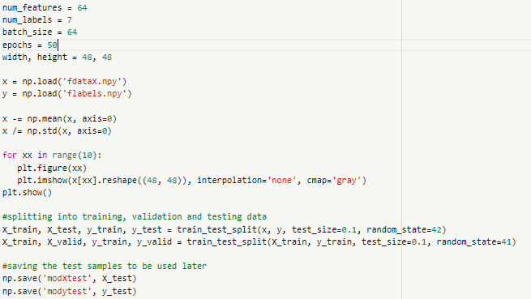

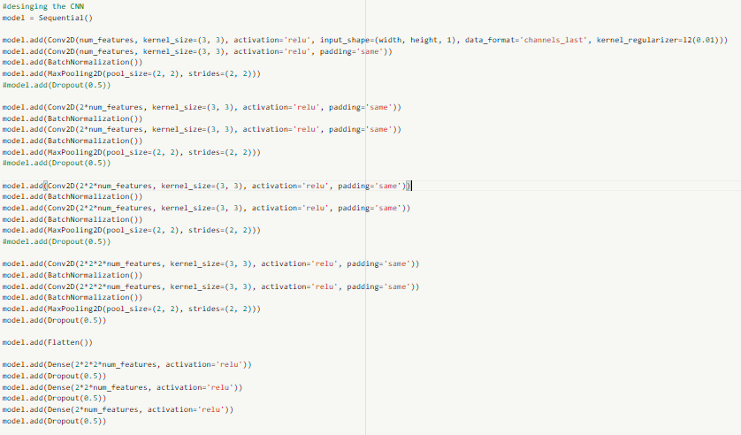

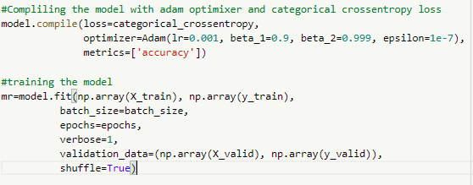

- Now, we have completed the training for our dataset and after running the training dataset for about 3 epochs, our training model‘s accuracy has come out to be around 30-31%. Now, we will launch our model into json and create this model. After the model is created, the calculated accuracy for our model comes out to be around 31.34%.

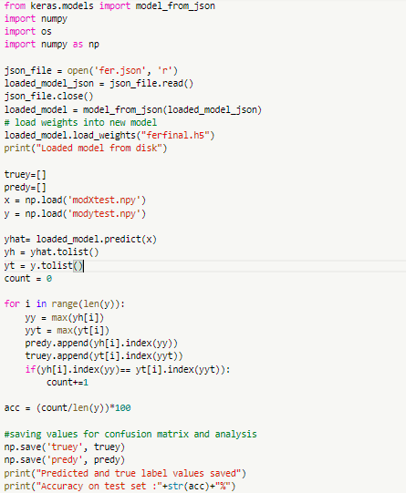

- After calculating the accuracy for our model, we will create a confusion matrix for our model and visualize the model.

.

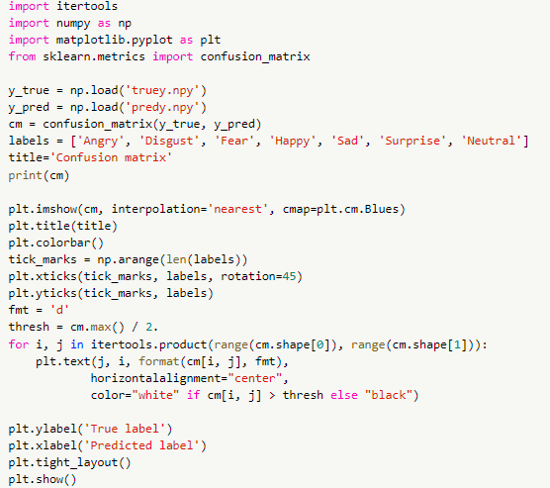

Confusion Matrix

Confusion matrix is a performance measurement for machine learning classification problem where output can be two or more classes. It is a table with 4 different combinations of predicted and actual values.

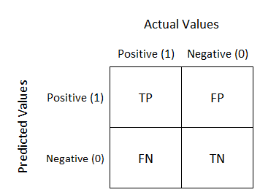

It is extremely useful for measuring Recall, Precision, Specificity, and Accuracy. Now in the given illustration of confusion matrix:
- TP – No of true positives
- FP – No of false positives
- FN – No of false negatives
- FP – No of false positives

- Now after creating the confusion matrix for the given model, we will calculate the f1_score for our model which comes out be to be 0.1420346354430285.

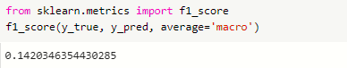

- Now we will compute the precision, recall, f_score and support for our model.

The precision is the ratio tp / (tp + fp) where tp is the number of true positives and fp the number of false positives. The precision is intuitively the ability of the classifier not to label as positive a sample that is negative.
The recall is the ratio tp / (tp + fn) where tp is the number of true positives and fn the number of false negatives. The recall is intuitively the ability of the classifier to find all the positive samples.
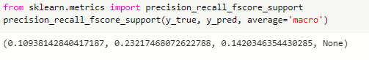
- At last, we will generate a classification report for our model which consists of all the metrics used in confusion matrix.

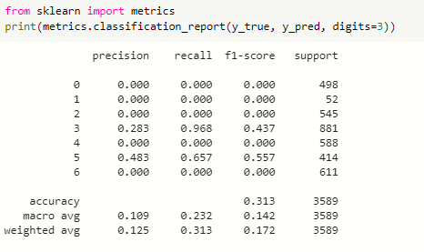

Code & Demo (Collecting Dataset & Training of Dataset)

import pandas
data = pandas.read_csv("fer2013.csv")

data.head(10)

print('Samples distribution across Usage:')
print(data.Usage)

print('Samples per emotion:')
print(data.emotion.value_counts())

print('Number of pixels for a sample:')
print(len(data.pixels[0].split()))

train_set = data[(data.Usage == 'Training')]
validation_set = data[(data.Usage == 'PublicTest')]
test_set = data[(data.Usage == 'PrivateTest')]

emotion_labels = ["Angry", "Disgust", "Fear", "Happy", "Sad", "Surprise", "Neutral"]
num_classes = len(emotion_labels)

import pandas as pd
import numpy as np
import warnings
warnings.filterwarnings("ignore")

width, height = 48, 48

datapoints = data['pixels'].tolist()

#getting features for training
X = []
for xseq in datapoints:
xx = [int(xp) for xp in xseq.split(' ')]
xx = np.asarray(xx).reshape(width, height)
X.append(xx.astype('float32'))

X = np.asarray(X)
X = np.expand_dims(X, -1)

#getting labels for training
#y = pd.get_dummies(data['emotion']).as_matrix()
y = pd.DataFrame(data['emotion']).to_numpy()

#storing them using numpy
np.save('fdataX', X)
np.save('flabels', y)

print("Preprocessing Done")
print("Number of Features: "+str(len(X[0])))
print("Number of Labels: "+ str(len(y[0])))
print("Number of examples in dataset:"+str(len(X)))
print("X,y stored in fdataX.npy and flabels.npy respectively")

import sys, os
import pandas as pd
import numpy as np
from sklearn.model_selection import train_test_split
from keras.models import Sequential
from keras.layers import Dense, Dropout, Activation, Flatten
from keras.layers import Conv2D, MaxPooling2D, BatchNormalization
from keras.losses import categorical_crossentropy
from keras.optimizers import Adam
from keras.regularizers import l2
from keras.callbacks import ReduceLROnPlateau, TensorBoard, EarlyStopping, ModelCheckpoint
from keras.models import load_model
from keras.models import model_from_json

num_features = 64
num_labels = 7
batch_size = 64
epochs = 50
width, height = 48, 48

x = np.load('fdataX.npy')
y = np.load('flabels.npy')

x -= np.mean(x, axis=0)
x /= np.std(x, axis=0)

for xx in range(10):
plt.figure(xx)
plt.imshow(x[xx].reshape((48, 48)), interpolation='none', cmap='gray')
plt.show()

#splitting into training, validation and testing data
X_train, X_test, y_train, y_test = train_test_split(x, y, test_size=0.1, random_state=42)
X_train, X_valid, y_train, y_valid = train_test_split(X_train, y_train, test_size=0.1, random_state=41)

#saving the test samples to be used later
np.save('modXtest', X_test)
np.save('modytest', y_test)

#desinging the CNN
model = Sequential()

model.add(Conv2D(num_features, kernel_size=(3, 3), activation='relu', input_shape=(width, height, 1), data_format='channels_last', kernel_regularizer=l2(0.01)))
model.add(Conv2D(num_features, kernel_size=(3, 3), activation='relu', padding='same'))
model.add(BatchNormalization())
model.add(MaxPooling2D(pool_size=(2, 2), strides=(2, 2)))
#model.add(Dropout(0.5))

model.add(Conv2D(2*num_features, kernel_size=(3, 3), activation='relu', padding='same'))
model.add(BatchNormalization())
model.add(Conv2D(2*num_features, kernel_size=(3, 3), activation='relu', padding='same'))
model.add(BatchNormalization())
model.add(MaxPooling2D(pool_size=(2, 2), strides=(2, 2)))
#model.add(Dropout(0.5))

model.add(Conv2D(2*2*num_features, kernel_size=(3, 3), activation='relu', padding='same'))
model.add(BatchNormalization())
model.add(Conv2D(2*2*num_features, kernel_size=(3, 3), activation='relu', padding='same'))
model.add(BatchNormalization())
model.add(MaxPooling2D(pool_size=(2, 2), strides=(2, 2)))
#model.add(Dropout(0.5))

model.add(Conv2D(2*2*2*num_features, kernel_size=(3, 3), activation='relu', padding='same'))
model.add(BatchNormalization())
model.add(Conv2D(2*2*2*num_features, kernel_size=(3, 3), activation='relu', padding='same'))
model.add(BatchNormalization())
model.add(MaxPooling2D(pool_size=(2, 2), strides=(2, 2)))
model.add(Dropout(0.5))

model.add(Flatten())

model.add(Dense(2*2*2*num_features, activation='relu'))
model.add(Dropout(0.5))
model.add(Dense(2*2*num_features, activation='relu'))
model.add(Dropout(0.5))
model.add(Dense(2*num_features, activation='relu'))
model.add(Dropout(0.5))

model.add(Dense(num_labels, activation='softmax'))

model.summary()

#Compliling the model with adam optimixer and categorical crossentropy loss
model.compile(loss=categorical_crossentropy,
optimizer=Adam(lr=0.001, beta_1=0.9, beta_2=0.999, epsilon=1e-7),
metrics=['accuracy'])

#training the model
mr=model.fit(np.array(X_train), np.array(y_train),
batch_size=batch_size,
epochs=epochs,
verbose=1,
validation_data=(np.array(X_valid), np.array(y_valid)),
shuffle=True)

Code & Demo (Calculating Accuracy for model)

# load json and create model
from __future__ import division
from keras.models import Sequential
from keras.layers import Dense
from keras.models import model_from_json
import numpy
import os
import numpy as np

json_file = open('fer.json', 'r')
loaded_model_json = json_file.read()
json_file.close()
loaded_model = model_from_json(loaded_model_json)
# load weights into new model
loaded_model.load_weights("ferfinal.h5")
print("Loaded model from disk")

truey=[]
predy=[]
x = np.load('modXtest.npy')
y = np.load('modytest.npy')

yhat= loaded_model.predict(x)
yh = yhat.tolist()
yt = y.tolist()
count = 0

for i in range(len(y)):
yy = max(yh[i])
yyt = max(yt[i])
predy.append(yh[i].index(yy))
truey.append(yt[i].index(yyt))
if(yh[i].index(yy)== yt[i].index(yyt)):
count+=1

acc = (count/len(y))*100

#saving values for confusion matrix and analysis
np.save('truey', truey)
np.save('predy', predy)
print("Predicted and true label values saved")
print("Accuracy on test set :"+str(acc)+"%")

import itertools
import numpy as np
import matplotlib.pyplot as plt
from sklearn.metrics import confusion_matrix

y_true = np.load('truey.npy')
y_pred = np.load('predy.npy')
cm = confusion_matrix(y_true, y_pred)
labels = ['Angry', 'Disgust', 'Fear', 'Happy', 'Sad', 'Surprise', 'Neutral']
title='Confusion matrix'
print(cm)

plt.imshow(cm, interpolation='nearest', cmap=plt.cm.Blues)
plt.title(title)
plt.colorbar()
tick_marks = np.arange(len(labels))
plt.xticks(tick_marks, labels, rotation=45)
plt.yticks(tick_marks, labels)
fmt = 'd'
thresh = cm.max() / 2.
for i, j in itertools.product(range(cm.shape[0]), range(cm.shape[1])):
plt.text(j, i, format(cm[i, j], fmt),
horizontalalignment="center",
color="white" if cm[i, j] > thresh else "black")

plt.ylabel('True label')
plt.xlabel('Predicted label')
plt.tight_layout()
plt.show()

from sklearn.metrics import f1_score
f1_score(y_true, y_pred, average='macro')

from sklearn.metrics import precision_recall_fscore_support
precision_recall_fscore_support(y_true, y_pred, average='macro')

from sklearn import metrics
print(metrics.classification_report(y_true, y_pred, digits=3))

Output

The following output tells us about the dataset.

The following snippets describes about the FER Dataset which includes the no of training images, validation images and test images.

This image is the output of Data pre-processing of dataset which defines the number of features and labels.

This is the output of the images present in the dataset which includes around 37000 images of person with different facial expressions.

After building up the CNN model and training the dataset and running the model for 3 epochs, we have following output

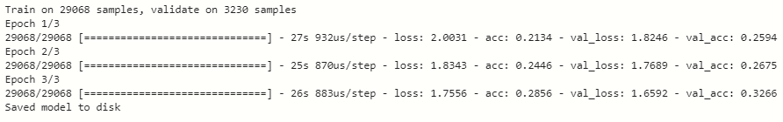

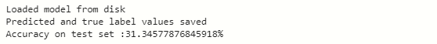

After the training of dataset, we compiled the dataset into a model and calculated the accuracy for the model which is around 31.34%.

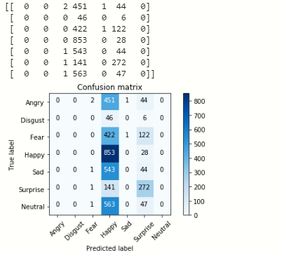

Then, we created the confusion matrix for the model which is given as above.

At the end, we created the summary for the classification report for our model.

System Requirements

- Operating System: Windows 10
- Minimum Hardware: 2 GB RAM, 1GB Free Hard Disk Storage, 32/64 – Bit Processor (Intel i5)
- Environment : Google Colaboratory (For Python)
- Programming Language to be used: Python 3.6
- Libraries: Keras, NumPy, Scikit-Learn, Matplotlib
- Dataset to be used: FER 2013 Dataset

Schedule

START
Study Period

Duration 1 weeks
Requirement gathering

Duration 1 week

Pseudo code
Duration 1 week
Design
Duration 2 week
Coding and implementation
Duration 4 weeks

Debugging
Duration 1 week

Testing
Duration 2 week
Publish Report
Duration 1 week

END

References

[1] https://www.kaggle.com/c/challenges-inrepresentation-learning-facial-expression recognition-challenge/data

[2] https://github.com/torch

[3] Dalal, Navneet, and Bill Triggs (2005). Histograms of oriented gradients for human detection. Computer Vision and Pattern Recognition (CVPR), IEEE Computer Society Conference on.Vol. 1

[4] Bettadapura, Vinay (2012). Face expression recognition and analysis: the state of the art. arXiv preprint arXiv:1203.6722

[5] Lonare, Ashish, and Shweta V. Jain (2013). A Survey on Facial Expression Analysis for Emotion Recognition. International Journal of Advanced Research in Computer and Communication Engineering 2.12

[6] Nicu Sebe, Michael S. Lew, Ira Cohen, Yafei Sun, Theo Gevers, Thomas S. Huang(2007) Authentic Facial Expression Analysis. Image and Vision Computing 25.12: 1856-1863

[7] Y. Tian, T. Kanade, and J. Cohn. Recognizing action units for facial expression analysis. IEEE Transactions on Pattern Analysis and Machine Intelligence, 23(2), 2001.

[8] M.S. Bartlett, G. Littlewort, M. Frank, C. Lainscsek, I. Fasel, and J. Movellan. Fully automatic facial action recognition in spontaneous behavior. In Proceedings of the IEEE Conference on Automatic Facial and Gesture Recognition, 2006.

[9] https://towardsdatascience.com/classification-using-neural-networks-b8e98f3a904f

[10] https://www.tutorialspoint.com/data_mining/dm_classification_prediction.htm

[11] https://www.javatpoint.com/classification-algorithm-in-machine-learning

End Semester Draft verified by

Project Guide HOD
(Name & Sign) (Dept. of Informatics)

